**Read at least 3 lines**

**All these courses are done by me in a time span of 2.5 years along with my graduation in BCA and GNIIT.**

There are more courses of different technologies, I have not completed yet intensely, because they contain very advanced topics, and I had no idea about when I will need them.

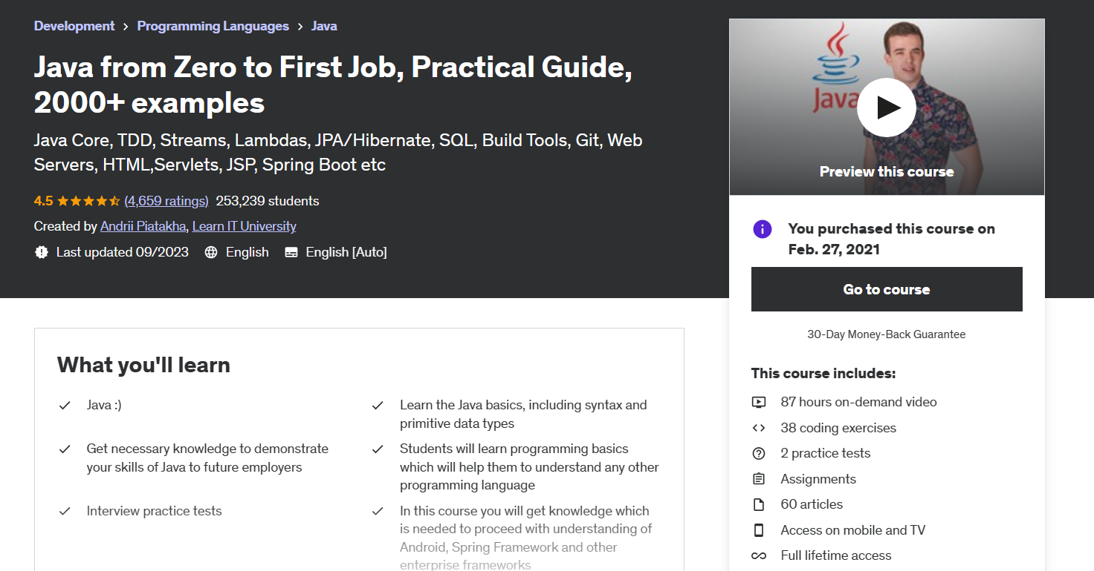

Like this **91.5hrs 2000+ examples course**, this course is awesome and amazing. It has content more than a pro java programmer needs to know, that's why I didn’t finish it.